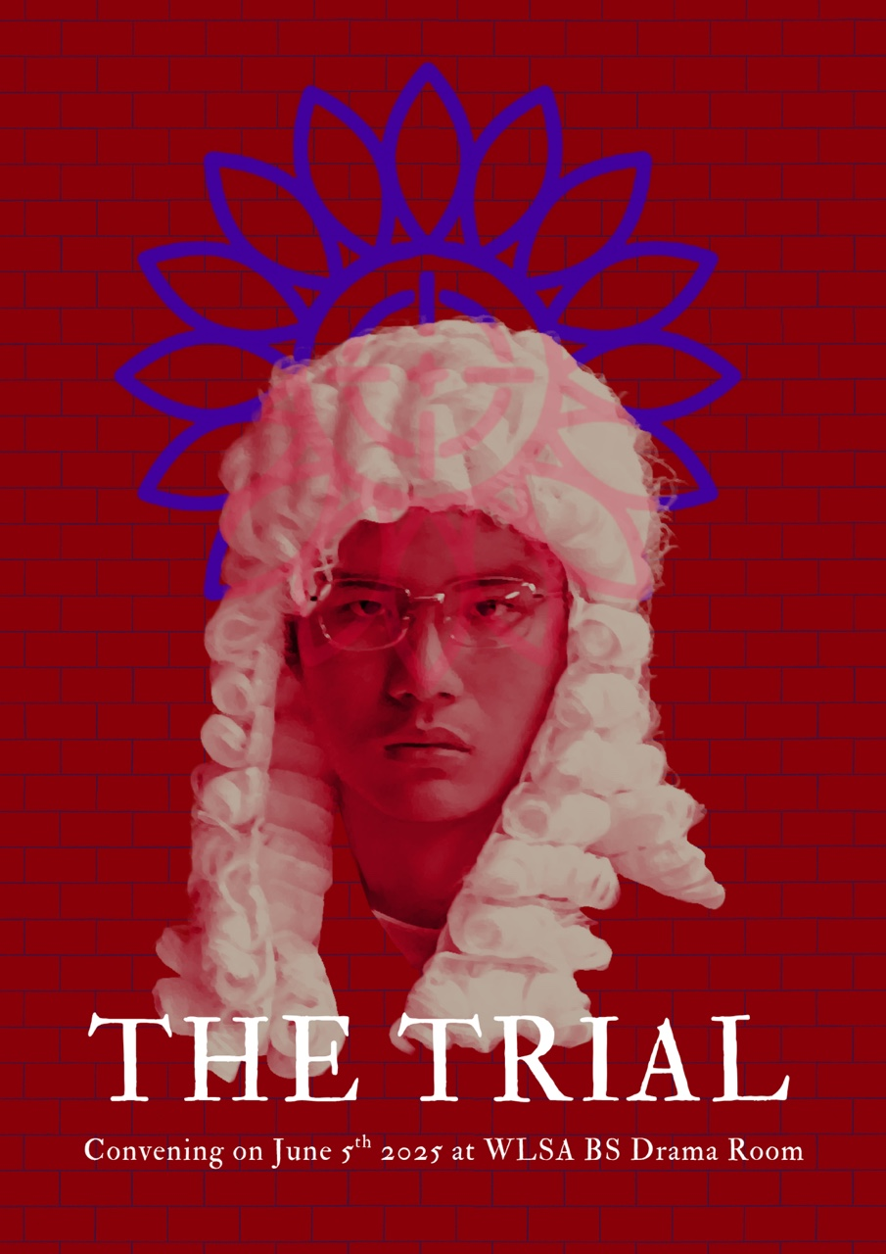

THE TRIAL
By: Angela Li

SETTING:
A surreal, ambiguous, dimly lit courtroom, neither fully modern nor historical. The stage is sparse and simple: a judge’s bench stands center-back, flanked by witness stands. The prisoner sits in the stage center while chairs are arranged for the other characters.
CHARACTERS:
ALEX, main character, an unmarried store clerk in his 30s who lives alone
FLORIST, government-verified distributer of sunflowers—the regime’s national flower; underground anti-government movement leader.
JUDGE, the judge of the court
PROSECUTOR, the prosecutor of the court
EXECUTOR, the executor of the court
DONNIE, witness, Alex’s next-door neighbor
SHERRY, witness, Alex’s childhood friend
JERRY, witness, Alex’s boss

SCENE 0: PROLOGUE
Outside the Assembly. Spotlight on the FLORIST, alone.
FLORIST:
(steps forward) Sunflowers are for the loyal, you see. Bright, upright things that always turn toward the light. They’re easy to sell. People like to believe they’re the loyal kind. As for the accused? No flowers for them. Not in my shop. Oh, don’t look so surprised — arranging bouquets isn’t so different from arranging a verdict. We all know our lines. When the Judge announces the verdict, you, the jury, answers, “Guilty!” Loud and proud, just like always. Now then… shall we begin the arrangement?
(EVERYONE enters the stage. The FLORIST holds up her arms to open the door.)

SCENE I: THE NATIONAL RITUAL
The Assembly. The room, large, dimly lit; the air, suffocating because of the dense crowd of the daily assembly at 6 o’clock in the morning to recite the national oath of allegiance. Everyone stands with their backs facing the audience, their fronts facing a flag hung before them on the wall with the nation’s emblem.
ALL:
In the name of the Sunflower, we vow to uphold the principles and values that sustain our harmonious society. We vow to suppress any seeds of sedition that may threaten the stability and harmony of our beloved nation.
May the Sun forever shine upon us and nurture our land with prosperity.
(Hold up right hand, close fist, open fist)
(ALEX paused mid-sentence as he recited the second sentence of the pledge and forgot to put his hand up after the oath is finished. SHERRY, standing behind her, notices his odd behavior.)
SHERRY:
(in a dramatic, loud voice) Alex, what’s wrong? Why didn’t you hold up your hand?
(ALL gasp in horror. Muffled queries and complains emerge from the crowd. A gunshot rings. The EXECUTOR runs onstage and drags ALEX downstage. All lights go down.)

SCENE II: THE TRIAL, PT.1
The courtroom.
(The FLORIST enters quietly and begins putting flowers next to each seat except ALEX’s.)
FLORIST:
(sung a cappella) Are you, are you
Coming to the tree?
They strung up a man
They say who murdered three
Strange things did happen here, no stranger would it be
If we met at midnight in the hanging tree.

(The FLORIST pauses, selects a single flower, and offers it to an audience member.)
FLORIST:
For you all—don’t lose it.
(The FLORIST exits. The rest of the cast enters and takes their places. ALEX sits cross-legged on the floor, unconsciously tracing the outline of his invisible wall on the ground. The others sit on their seats.)
PROSECUTOR:
Good Morning, your Honor, with the utmost respect and deepest admiration—your fairness and wisdom precede this courtroom! We gather today to consider the case of not just a man, but a menace to our order, Alex—charged with the gravest of modern sins: (read the scroll) Antisocial Conduct and Failure to Participate in Collective Life.
JUDGE:
(Read court directions off a scroll, speaking directly to the audience)
“Members of the jury, your duty today will be to determine whether the plaintiffs prove that the defendant committed Antisocial Conduct detrimental to the interests of the Republic. You must find a verdict based on a preponderance of the evidence, or the most convincing...” (pauses abruptly)
(raise spare hand to signal at the audience, grinning at PROSECUTOR) Prosecutor, how about we keep things lively for this slumberous jury?
PROSECUTER:
(bow) Very well, your honor. Your wish is my command.
Now calling to the stand—
(SHERRY begins to talk as she quickly walks upstage)
SHERRY:
Alex wasn’t always like this. We used to play together, recite the pledge at school—he was so bright! But now—he barely looks at anyone. He’s closed off. Distant. Almost like he’s built himself a wall. At the last assembly, he didn’t finish the oath, and, oh Lord (feigning dizziness) he wouldn’t even raise his hand to make the sunflower sign. (leans toward Judge, syrupy) Such a shame, Your Honor. I nearly fall to my knees when I recite my oath. I always say, it’s the quiet ones you gotta watch. I worry about him, Your Honor. I really do.
(DONNIE walks upstage as SHERRY speaks her last sentences, bumps into her shoulder, and takes her place. SHERRY leaves the stage with a slightly irritated expression.)
DONNIE:
(speaking in a high-pitched voice) Alex? Oh, don’t get me started! Eight years living next door to him feels like eighty. What a life!
(holds his forehead annoyedly, sighing dramatically) That man drifts about like a nowhere man. (point at ALEX) He’s clearly not dedicating himself to our Supreme Leader!
And you know what? He doesn’t even own a flag! (breaks into a fit of laughter) Can you believe it? A man without a flag! It’s like he’s not even a part of our great nation! I’ve got flags in my bedroom, flags in my living room, flags in my bathroom—I even sleep with a flag pillow! And Alex? He probably sleeps next to his takeout bags or something!
(JERRY walks upstage, adjusting his tie and straightening his suit. DONNIE takes one look at him and runs offstage in fear.)
JERRY:
(scratching his head, quietly, as if talking to himself) Alex seems alright…what’s this trial for anyway, what could I possibly accuse him of?
(The JUDGE clears his throat and stares at JERRY intently.)
JERRY:
Ah yes, yes, I remember. (snaps back into place, in a booming voice) Your Honor, I run the largest retailer corporation in the city. I am used to running a tight ship. All my employees strictly conform and even go out of their ways to surpass the mandatory 996 schedule. Alex is the only employee who would never come to work early or work until midnight. What’s his problem—what more does he have to do besides being a salesclerk?
(in an exaggerated, melodramatic voice, waving his arms for emphasis) What’s more, Your Honor, Alex is more than a misfit, he is trying to subvert our social order! He covers for one for his colleagues whose car broke down one morning, saying he had a heart attack instead! Alex, though it is true that your colleague died of heart attack that afternoon, you are not allowed to cover for your colleagues when they did something wrong or treat them like (grimacing, making air quotes) friends! Do you realize how many industry chains will break down if everyone acts your way?
(All witnesses cheer in support of JERRY’s words. DONNIE runs up to JERRY as he leaves the stage, shaking JERRY’s hands and mouthing words of gratitude as he accompanies and leads JERRY offstage.)

JUDGE:
(Bangs gavel) Order, order! Members of the jury (signaling the audience), you may now retire to deliberate your verdict.
(The JUDGE begins to walk offstage.)
SHERRY:
(In a honeyed, flattering voice) Your honor, please, regarding the position in the court you were considering for me earlier—
(SHERRY tags behind the JUDGE. Everyone except ALEX leaves the stage. Lights dim. Ominous rumbling. ALEX sits, feeling the invisible wall.)
End of Scene

SCENE III: THE INTERLUDE
Spotlight on ALEX, alone. The courtroom fades away. All seats are taken offstage; the stage is empty, with only a ray of white light shining from above down on ALEX.
(One by one, the three “witnesses”—SHERRY, DONNIE, JERRY—re-enter as grotesque versions of themselves, circling ALEX, taunting. ALEX curls up with his knees in his arms in fear.)
SHERRY:
You’re broken, Alex. You’ll never belong. (giggles cruelly)
DONNIE:
(fanning his hands) Get away! You disgust me!
JERRY:
(kneels and wraps his arms around ALEX, speaking in a low, charismatic voice) Consider sentencing yourself to life imprisonment in my corporation. (cackles)
(DONNIE, SHERRY and JERRY banter among themselves as they leave the stage. The FLORIST enters the stage and hands a flower to ALEX.)
ALEX:
(finds a message at the back of the flower and reads it aloud) “Don’t give in without a fight.”
FLORIST:
You know, there’s something between you and the world. Can you feel it?
(ALEX holds out his hand and feels the wall. He hesitates. Then, he knocks on it. ALEX turns to look at the FLORIST with a perplexed expression on his face.)
ALEX:
(Quietly) I… I don’t know. Sherry used to say I just won’t grow up, but…honestly, there must be a wall between me and everyone else.
We have all been taught to measure our words and program our reactions. But…but—the sunflowers every week on our doorsteps. (brings out a crumpled piece of wrapping paper from his pocket and lays it open) Look. Someone has been writing in my wrapping papers. Telling me how the oath we recite at the Assembly is a lie—it made no sense to me at first. But then, the messages turned serious. They said there were deeper things than fear and anger. There’s love. Trust. A whole spectrum of emotional complexity somewhere out there.
And it hurts, because…because… I think I’ve been controlled all my life. That’s why I don’t have that part in me. I don’t know who does. I’m confused. I’m scared…I can’t feel anything properly anymore. (crumples the wrapping paper again and slowly puts it back into his pocket)
I just have to know (turns to the FLORIST) —what’s the point of living… if you don’t feel anything?
(The FLORIST kneels beside ALEX, her hand reaching out to touch ALEX’s wall, but stops short, hovering in the air.)
FLORIST:
Most people never notice. But you do. There is a wall, Alex.
ALEX:
But how did you get into my head—how did you get past this wall?
FLORIST:
I didn’t climb over, Alex. I waited at the gate. Sometimes, the smallest crack is enough—a question, a memory, a moment you refuse to let go. That’s all it takes for something real to slip through.
ALEX:
(turning the flower over in trembling hands) But what if the crack closes? What if I forget how to open it again?
FLORIST:
Then you find another. Or you make one.
(The FLORIST holds out her hand to feel ALEX’s wall again. Then, the FLORIST punches at ALEX’s wall. The wall slightly cracks, and debris begins to fall. )
They will always try to seal you in, tell you the walls are for your own good. But you already know they’re not. You already ache for what’s outside.
ALEX:
(voice breaking) But I’m scared…not just of them, but of what’s left of me. What if I step out and everything turns out just the same?
FLORIST:
Emptiness is the space where something new—flowers, too—can grow. You’re not empty, Alex. You’re waiting. You’re listening. That’s more than most dare to do.
ALEX:
(softly, almost to themself) Don’t give in…without a fight.
FLORIST:
(smiles) Exactly. The world wants you numb, Alex, but you—(pauses, placing a gentle hand on Alex’s shoulder) You still notice the ache. That’s where hope will begin to grow.
Alex—do continue to look out for those sunflowers on your doorstep. They are sent by my girls, you know. I know very well who should be receiving the messages. (winks)
(The FLORIST stands up and backs away, fading into the darkness, leaving ALEX alone in the spotlight, clutching the flower.)
ALEX:
(slowly stands up, voice steadier) Maybe… all it takes is one crack—one question—to let the light in through the wall. (pauses)
(to himself, looking at the audience) Alex. What more will you make use of your dire life?
End of Scene

SCENE IV: THE TRIAL, PT.2
The courtroom reappears.
All witnesses and officials re-enter the stage and puts their chairs back in place.
JUDGE:
We are back in session. (Bangs gavel) I have received the verdict reached by the jury. This court will now announce its verdict.
Alex, you have been found—(glances at audience)—guilty or innocent? (waits for response from the audience, then continues)
Guilty, by the wisdom of the people!
(The witnesses cheer. ALEX stands up abruptly.)

ALEX:
No! I refuse…this is pure…absurdity! (tugs at the hems of his shirt. Seeing the silence and surprised expression around him, lets go of his shirt and musters up courage to continue) This isn’t a court for justice, it’s theater! It’s nothing but a play that you (points at JUDGE) have put on! You’re no more honorable than a pig!
(ALL gasp in horror.)
And as for all of you… (points at audience) you are doing nothing but selling your souls for another day of safety.
(steps forward, voice rising) You want to break me, to grind me down until I clap and smile on cue! You want us to cheer as you cage us, to thank you for the shackles!
(voice lowered, trembling with fury and grief) Well, I will act my part in this play no longer. (raises voice) Whoever wrote this play for me, I won’t recite my lines anymore. Tear down your sets, strip off your costumes—what’s left? (points at his own chest) It’s null! Void! Emptiness!
(pauses, breathless) You can sentence me, you can break my body, but you…(turns back at JUDGE) you… will never win.
JUDGE:
(bangs the gavel violently) Silence! This is contumacy! Good lord, where on Earth are your manners? Are you not afraid of a death sentence here and now, Alex? (voice softening) My poor, poor boy! What has happened to you?
ALEX:
No! Nothing—
(SHERRY steps forward, pleading to the Judge.)
SHERRY:
(interrupting ALEX) Alex wasn’t always like this! Someone must have corrupted him!
(DONNIE and JERRY marches forward as SHERRY speaks. DONNIE pushes SHERRY offstage.)
DONNIE:
(pointing at ALEX) Your Honor! Why does Alex have a sunflower in his hand?
JERRY:
Does he think he’s earned this? Does he think his mere presence warrants such an honor? (throws his arms wide) It’s an affront to our national flower, Your Honor!
(leans in close to ALEX) Alex, old chap, have you no shame? Your hands are filthy with the mud of apathy. They’ve never fought for your country—you have no national pride in you, Alex. What right do you have to hold that sunflower in your hands?

JUDGE:
Bring forth the Florist!

(The EXECUTOR drags the FLORIST onstage.)
FLORIST:
(calmly) Your honor, I remain innocent until proven guilty.
JUDGE:
So! It was you, the humble florist, sowing seeds of rebellion with our most sacred national flower!
FLORIST:
I haven’t done anything else, your honor. All I did was give him a sunflower—
JUDGE:
Silence! Who gave you the right to profane the court with your protests? You dare to distribute the sunflower, the symbol of our nation’s unity and prosperity, to those who would seek to disrupt the harmony of our society? You have violated the very essence of our national law!
You have committed the gravest crime, and for this, you stand accused, of sedition—no, worse! Of treason! Of poisoning the very roots of our order!
(the EXECUTOR begins to drag the FLORIST offstage.)
FLORIST:
(speaking quickly, strugging to stand back in place) Your Honor, I was ordered to distribute the sunflower to everyone regardless of their beliefs. I was unaware that my actions could be perceived as a legal violation. Please, I would like to follow formal court procedures and provide any necessary information to clear my name and prove my innocence!

EXECUTOR:
(threateningly, in a roaring voice) Silence!
FLORIST:
(to Alex) Alex, take my place! Tear down your wall!
(The EXECUTOR drags the FLORIST to the edge of the stage and puts a gun to her head. A gunshot rings out. At the same instant, the wall around ALEX crumbles to the ground. ALEX reaches out and feels for the wall, but there’s nothing there. He steps forward and begins to walk out, but he decides to turn around to look one last time. There, he spotted the FLORIST’s dead body. Realization and grief immediately flood his face.)
ALEX:
(whispers shakily) No… I didn’t… Wasn’t that…the collapse of…my wall?
I don’t understand…
(As ALEX speaks, he staggers, collapses, sobbing. He crawls backward until he’s pressed against the real, physical wall at the edge of the stage—right beside the JUDGE’s hands. ALEX frantically feels for the physical wall behind his back and heaves a sigh of relief.)
ALEX:
(shakily) It’s real…it’s all real…
(The JUDGE picks up the flower next to him and hands it to ALEX, who accepts it with trembling hands. ALEX breaks down into traumatized wailing)
JUDGE:
No Alex…it’s all just a bad dream.
(The JUGDE signaled the EXECUTOR to come upstage and inject a tube of chemicals into his neck. ALEX’s head lowers as he slips into coma.)
JUDGE:
(soothingly) Good boy.

END OF PLAY

